Sahil Gawande

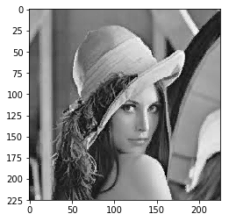

B05

Reg no: 2016bec05

import numpy as np

import cv2

from matplotlib import pyplot as plt

img = cv2.imread(r'C:\Users\COMPLAB_USER\lena_gray.jpg', 0)

plt.imshow(img, cmap='gray')

bs = 12

A = np.array(np.zeros([bs, bs]))

w = int(226/bs)

B = np.array(np.zeros([w*bs, w*bs]))

for i in range(0, w):

for j in range(0, w):

q = 0

patch_img = img[i*bs:i*bs+bs, j*bs:j*bs+bs]

mean = np.mean(patch_img)

sd = np.std(patch_img)

for m in range(bs):

for n in range(bs):

if patch_img[m][n] > mean:

A[m][n] = 1

q = q+1

else:

A[m][n] = 0

if q == 0:

a = mean

b = mean

else:

a = mean - (sd*(np.sqrt(q/((bs**2)-q))))

b = mean + (sd*(np.sqrt(((bs**2)-q)/q)))

for m in range(bs):

for n in range(bs):

if A[m][n] == 0:

B[i*bs+m, j*bs+n] = a

else:

B[i*bs+m, j*bs+n] = b

plt.imshow(B, cmap='gray')

Input bs = 8 bs = 32

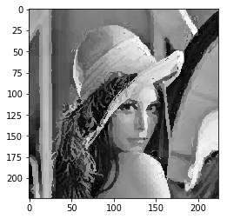

Btc__ip btc_op_bs_8

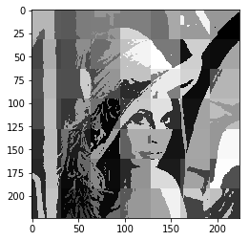

Btc_op_bs_32